
National University of Sciences & Technology (NUST) Balochistan Campus (NBC), Department of Computer Science
Department of Computer
Science
CS 250: Data Structures and
Algorithms
Class: BS(CS) 3rd Semester
Lab 10: Binary Search Tree
CLO1: Understand the fundamentals of data structures and algorithms.
Date: December 11th, 2024
Time: 10:00 AM - 1:00 PM
Lab Engr: Safder ali

NAME | SAMEER TALREJA
CMS | 457795

CS 250: Data Structures and Algorithms Page 1

National University of Sciences & Technology (NUST) Balochistan Campus (NBC), Department of Computer Science
Lab 10: Implementation of Binary Search Tree
Introduction
This lab is based on the implementation of Binary Search tree and its functions.
Objectives
The objectives of this lab are the following:
• Become familiar with implementation of binary search trees
• Study some statistics of binary search trees
• Write simple applications using binary search tree
Tools/Software Requirement
Visual Studio 2012 or gcc or g++
Description
In computer science, a binary search tree (BST), which may sometimes also be called an ordered or sorted binary tree, is a node-based binary tree data structure which has the following properties:
• The left sub-tree of a node contains only nodes with keys less than the node's key. • The right sub-tree of a node contains only nodes with keys greater than the node's key. • Both the left and right sub-trees must also be binary search trees.
• There must be no duplicate nodes.
In this lab, you will expand implement binary search tree, study some statistical properties of BST and write a simple application using the BST.
Here is a template of how your class/structure looks like.
classBST_Node{
Template data;
BST_Node * LeftChild;
BST_Node* RightChild;
};
CS 250: Data Structures and Algorithms Page 2

National University of Sciences & Technology (NUST) Balochistan Campus (NBC), Department of Computer Science
Lab Task
You are required to upload the lab tasks on Google Classroom and the name of that tasks must be in thisformat
FullName_reg#_task#.cpp
Remember to comment your code properly. Inappropriate or no comment will results in deduction of marks.
You are already provided with the basic implementation of Binary Search Tree. Run the code and you are required to do the following.
Tasks
Implement the following operations of Binary Search Tree ADT
1. Write main method that calls insert on user’s request. After the addition the resultant tree must be printed
2. Modify the Insert function so that it handles the duplicate values. The left sub-tree of any node shall contain items that are less than the root. Items that are equal to or greater than the root must go to the right.
3. Write a function to find the minimum value in a BST
4. Write a function to calculate the height of the BST

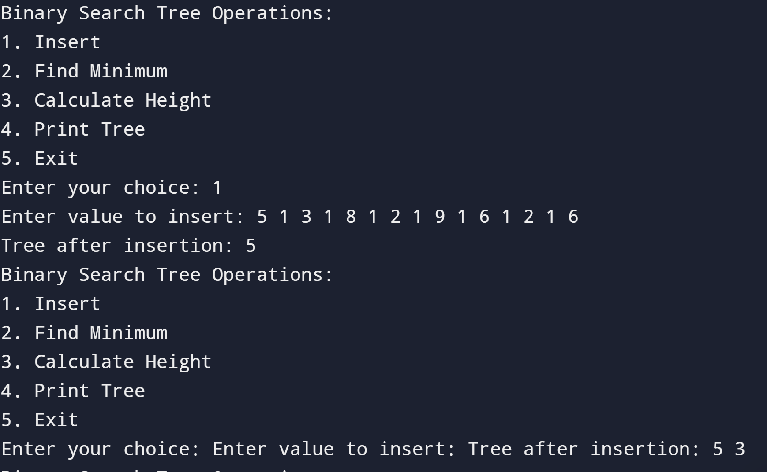
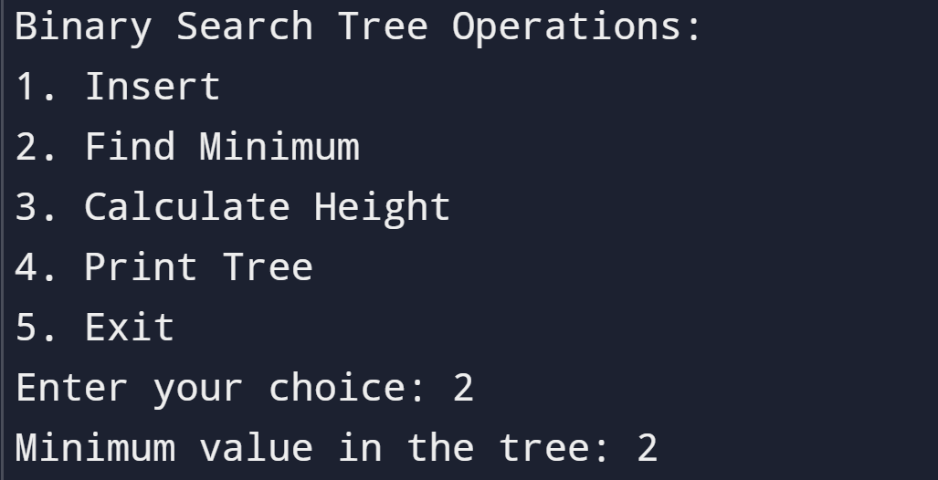
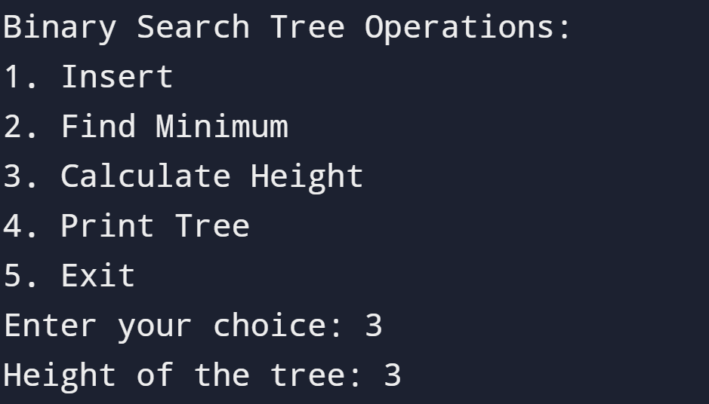
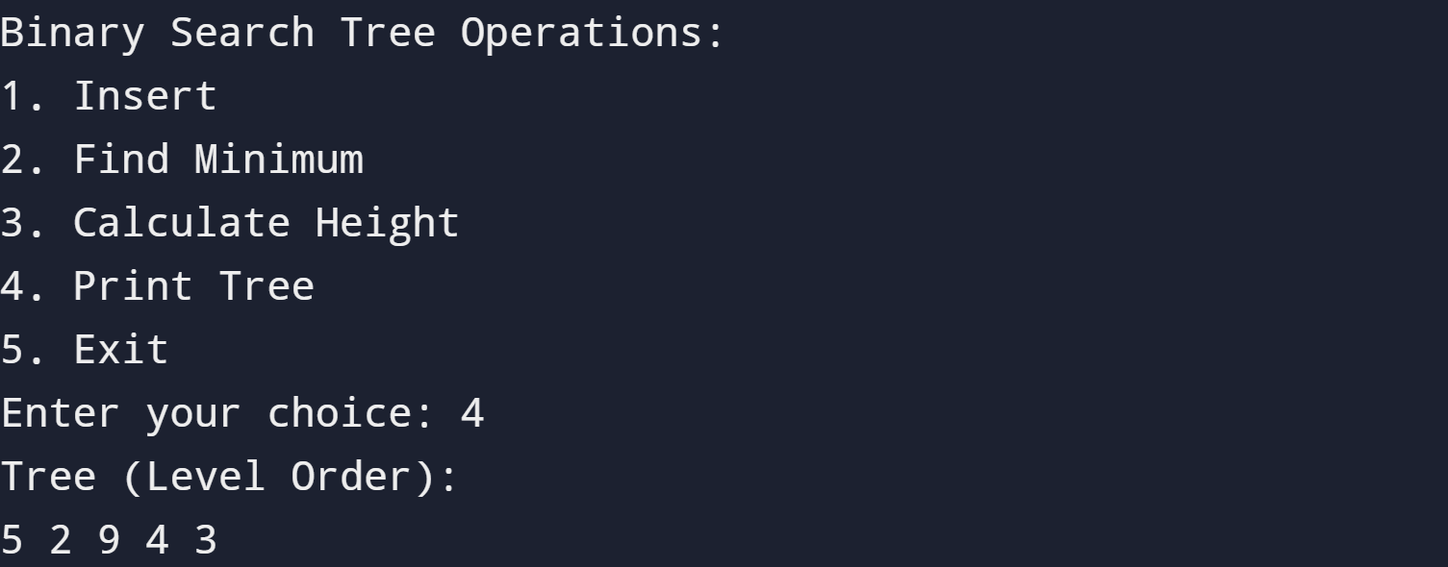
#include <iostream>
#include <queue>
using namespace std;

// A class to represent a node in the binary search tree (BST)
template <typename T>
class BST_Node {
public:
T data; // The actual value stored in the node
BST_Node* left; // Pointer to the left child
BST_Node* right; // Pointer to the right child

BST_Node(T value){
this->data=value;
this->left = NULL;
this->right = NULL;
}
};

// A class to represent the entire binary search tree (BST)
template <typename T>
class BinarySearchTree {
private:
BST_Node<T>* root; // The root node of the tree

// function to insert a value into the tree recursively
BST_Node<T>* insert(BST_Node<T>* node, T value) {
// If we've reached an empty spot, create a new node
if (!node) {
return new BST_Node<T>(value);
}
// If the value is smaller, go to the left subtree
if (value < node->data) {
node->left = insert(node->left, value);
}
// If the value is equal or larger, go to the right subtree
else {
node->right = insert(node->right, value);
}
return node; // Return the unchanged node pointer
}

// function to find the minimum value in the tree
BST_Node<T>* findMin(BST_Node<T>* node) {
// Keep moving to the leftmost node
while (node && node->left) {
node = node->left;
}
return node; // This is the node with the smallest value
}

// function to calculate the height of the tree
int height(BST_Node<T>* node) {
// Base case: An empty tree has a height of -1
if (!node) return -1;
// Recursively calculate the height of left and right subtrees, and add 1
return 1 + max(height(node->left), height(node->right));
}

// Helper function to print the tree in level order
void printTree(BST_Node<T>* node) {
// If the tree is empty, inform the user
if (!node) {
cout << "Tree is empty." << endl;
return;
}
// Use a queue to traverse the tree level by level
queue<BST_Node<T>*> q;
q.push(node); // Start with the root node
while (!q.empty()) {
BST_Node<T>* current = q.front();
q.pop();
// Print the current node's value
cout << current->data << " ";
// If the current node has a left child, add it to the queue
if (current->left) q.push(current->left);
// If the current node has a right child, add it to the queue
if (current->right) q.push(current->right);

}
cout << endl; // Print a newline after printing all nodes
}

public:
// Constructor to initialize an empty tree
BinarySearchTree() {
this->root=NULL;
}
// Public function to insert a value into the BST
void insert(T value) {
root = insert(root, value);
}

// Public function to find the smallest value in the BST
T findMin() {
BST_Node<T>* minNode = findMin(root);
if (minNode) return minNode->data; // If the tree isn't empty, return the minimum value
throw runtime_error("Tree is empty."); // Throw an error if the tree has no nodes
}

// Public function to calculate the height of the BST
int height() {
return height(root);
}

// Public function to print the BST (level-order traversal)
void printTree() {
printTree(root);
}
};

int main() {
BinarySearchTree<int> bst; // Create an integer-based BST
int choice, value;

while (true) {
// Display a menu to the user
cout << "Binary Search Tree Operations:"<<endl;
cout << "1. Insert"<<endl;
cout << "2. Find Minimum"<<endl;
cout << "3. Calculate Height"<<endl;
cout << "4. Print Tree"<<endl;
cout << "5. Exit"<<endl;
cout << "Enter your choice: ";
cin >> choice; // Read the user's choice

switch (choice) {
case 1:
// Insert a value into the tree
cout << "Enter value to insert: ";
cin >> value;
bst.insert(value);
// Show the tree after the insertion
cout << "Tree after insertion: ";
bst.printTree();
break;
case 2:
// Find and display the smallest value in the tree
try {
cout << "Minimum value in the tree: " << bst.findMin() << endl;
} catch (const runtime_error& e) {
cout << e.what() << endl; // Handle the case when the tree is empty
}
break;
case 3:
// Calculate and display the height of the tree
cout << "Height of the tree: " << bst.height() << endl;
break;
case 4:
// Print the tree (level-order traversal)
cout << "Tree (Level Order): "<<endl;
bst.printTree();
break;
case 5:
// Exit the program
cout << "Exiting program." << endl;
return 0;
default:
// Handle invalid menu options
cout << "Invalid choice. Please try again." << endl;
}
}
}

Deliverable
Students are required to upload the lab task on Google classroom before the deadline. The lab is graded between 0 to 10 marks. The submitted solution can get a maximum of 5 marks. At the end of each lab or in the next lab, there will be a viva related to the tasks. The viva has a weightage of 5 marks. Insert the solution/answer in this document. You must show the implementation of the tasks in the designing tool, along with your complete Word document to get your work graded. You must also submit this Word document on the LMS / google classroom. In case of any problems with submissions submit your Lab assignments by emailing it to Safder Ali: students.em96@gmail.com.
CS 250: Data Structures and Algorithms Page 3

